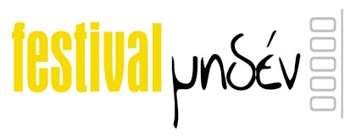

ΔΕΛΤΙΟ ΤΥΠΟΥ

Video Art Festival Μηδέν
8, 9, 10 July, 2010
Historic Centre of Kalamata

Video art… strikes back!

Video Art Festival Miden is ready to strike again this summer inviting us on a journey to the visual universe of contemporary global video-creation. An adventurous as much as delightful trip to the thoughts and quests of the avant-garde video-artists of the new generation who reflect the most sharp and interesting trends of contemporary art.

Festival Miden will take place at the traditional neighborhoods of Kalamata’s Historic Centre, at Amfias square, in July 8-10, 2010 (9.30 pm), with free entrance.

In its sixth realisation, more than 800 videos were submitted from every part of the world. During the three nights of the festival a selection of 181 videos will be presented, including tributes to foreign festivals and art-groups and interactive programs and installations.

The basic program includes the following theme screenings:

Main screening:

- Supernatural
Maria Bourika, guest curator for this screening notes: “Is it matter of a hollow mind? Seems to wonder Kathlene Krallowek in her video “Gardens of Mirrors”. Through folk culture, sience fiction, horror films and the uncanny life-like androids, humanity likens to explore the hidden aspects of itself and reveal them in dreams, myths and fantasies, until they find their place in a new hyper-reality”.
- Upstream Eyeglasses
Experimental animations which draw the curtains, balances of form and context, diving in memory, flights in every day life, nostalgia and arrogant gestures that self-subvert.
All have one thing in common: upstream views.
- land/e/scape
Mariaggela Koutiva and Olga Brouma, two young architects that have been invited by the festival to curate a screening oriented towards the exploration of space, digital or non-digital, suggested the specific title. They note: “Escape. Escapement following a line on a sheet, the captive climbs on the mountain, digging the dirt leaving traces, scars ephemeral or chronic on his face. The land defines him. When it burns him, he will be reborn.”
- Sound & Vision
One of the most loved “obsessions” of the festival, the relationship between sound and music with the imagery and the vision of the creator. It’s worth noticing the presence of Marie Losier, with her brilliant work “Slap the Gondola!”, featuring legendary avant-garde artists Tony Conrad and Genesis P-Orridge, along with Q. Tarantino’s muse April March.
- Just a Cause
What is left from the concept of political and social art in our era and to what level can contemporary artists approach it? Subjects such as immigration, states and borders, ecology, consumerism, gender issues, the digital era etc. through connotations, humor or direct positions.
- The Moneying of Life
The most crucial and constant concern of the globalized village over the last two years, directing lives and shaping realities. Is it a game of Tombola (as in the video of Laura Mergoni, from which the festival borrows the image for this year’s poster), or even worse a casino? Is moneying the meaning of life? What will the clouds of the Nigerian artist Emeka Ogboh (in the last video of the festival) bring?

Parallel screening:

VIDEOCHANNEL: Found Footage!



The online platform “VideoChannel-video project environments”, based in Cologne, Germany, has been established as a significant international database for video art, featuring videos, screening projects and curatorial contributions from local and international festivals from all over the world.
“Found footage” is a filmmaking term which describes a method of compiling films partly or entirely of footage which has not been created by the filmmaker, and changing its meaning by placing it in a new context. The term refers to the “found object” (object trouvé) of art history.” The program is curated by Wilfried Agricola de Cologne.
http://videochannel.newmediafest.org/

ART BY CHANCE
ART BY CHANCE is a mobile festival based in Turkey and promoting international artists and works of small duration (under 1minute). The festival presents curated screening programs in various cities all over the world, in digital signage points and digital screens in unexpected places. Internationally selected and themed creative short films catch you unexpectedly while travelling in the subway, waiting at the airport, shopping or just strolling around, adding more art and colour to city life and city culture.
Festival Miden presents their most recent selection, themed “Time”.
http://www.artbychance.org/

CINEMATHEQUE: FLASH & THUNDER – an interactive exhibition




Flash & Thunder is a special interactive exhibition of Flash works, curated & programmed by Wilfried Agricola de Cologne for Cinematheque online platform. The program explores Flash as a medium and tool for artistic creations. The software program "FLASH" represents a vector based developing environment, which enables the creator to combine different media and develop vector based animations especially for the Internet. Artists captured it for artistic purposes, and it became one of the most popular software tools for the net, computer based animations and interactive applications like games.
http://cinema.nmartproject.net/cinema_d/flash-feature.html

CRONOSFERA: VISIONS FROM THE FUTURE - IRIDESCENT WORLDS

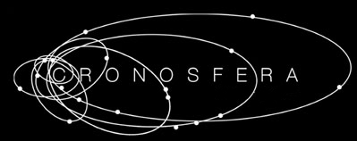

A very interesting video art and new media festival that fuses Cinema, the Audio-Visual world and new technologies, conjugating Science and Art, based in Torino, Italy. Cronosfera presents a special selection from its recent 2010 edition “Visions from the future – Iridescent worlds”.
“Visions from the future – Iridescent worlds” turns bright looks to the earth and the sky inspired by cosmological and cosmogonic visions, explores the alchemy of our earth, our history, the social evolution, spirituality and the mysteries surrounding man.
Curators: Luisa Mizzoni [alias luxi lu], Emilio Corti, Francesca Mizzoni [alias Infrason]
http://www.cronosferafestival.com/

4 NOW

Theodoros Zafeiropoulos, Konstantinos Tiligadis, Ronnie Cramer and Makis Faros. Four remarkable artists. A virtual coexistence.

FixC: FIXATION

Helsinki-based FixC is an independent artists co-operative, which was launched to generate, distribute and promote video art, media art and experimental cinema and to produce curated touring exhibitions and screenings. They present in Festival Miden a program entitled “FIXATION”, a journey through many worlds of moving image works, made by 6 FixC co-operative artists.
http://fixc.fi/

DEPARTMENT OF AUDIO & VISUAL ARTS – IONIAN UNIVERSITY

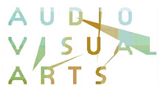

Marianna Strapatsaki, an acclaimed Greek video-artist and Professor of the Department of Audio & Visual Arts, Ionian University, Corfu, Greece, curates a special screening, presenting student videos from the Department of Audio & Visual Arts.
http://www.ionio.gr/depts/avarts/

BLACK DUCK & RED NOMADE


BLACK DUCK undertakes curatorial projects to promote the work of contemporary artists working in performance, installation, digital media and video to an international audience. Projects include participation in festivals, international exchanges, exhibitions and events.
RED NOMADE is an international cooperation project interested in the exchange of contemporary artists and intellectuals aiming to generate artistic, cultural and academic events in different cities in order to facilitate the meeting of visual artists, art critics, curators, writers and intellectuals.

RED NOMADE and BLACK DUCK present in Festival Miden a program with recent works by 10 artists, curated by Cristina Ghetti and Ima Picó. http://www.blackduckarts.blogspot.com/, http://www.red-nomade.com/

ANGELOS CHRONIS: Pixels Dance

PixelsDance is an interactive installation that investigates the interaction of the body with the screen. Through the manipulation of a pixels field and the generation of sound, it provokes the viewer to transform the virtual space. A "pixels dance" is thus generated, translating the gestures of the performer to an evolving visual and music performance.
Angelos Chronis studied Architecture and currently follows an MSc course on Adaptive Architecture & Computation, at Bartlett School of Graduate Studies, University College London.

-----------------------------------------------------------------------------

Festival Miden

Organization-production:



Sea Level (Urban-Non profit Company)

Art director – curator: Giorgos Dimitrakopoulos.

Curating of tributes and collaborations: Gioula Papadopoulou.

Guest curators: Maria Bourika, Mariaggela Koutiva, Olga Brouma.

Technical support: Stavros Kapetis

Assistance: Margarita Stavraki, Sibel Amet, Nikos Syrigos, Stavroula Baka

Web design: Giorgos Polychronidis, Christos Tsamardas

Poster-catalogue image: Laura Mergoni

www.festivalmiden.gr – info@festivalmiden.gr
Under the auspices of:

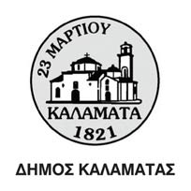

Communication sponsors:



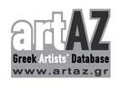



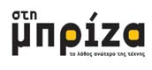





Supporters

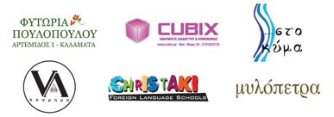

Supported by the Historic Centre of Kalamata Organization
and the Messinian Chamber of Commerce.

