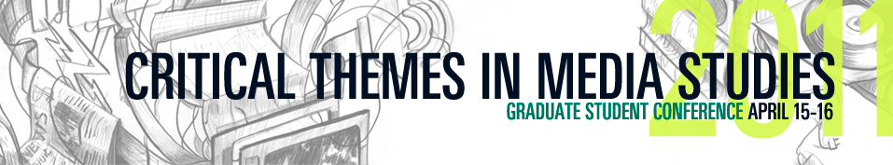
11th ANNUAL CRITICAL THEMES IN MEDIA STUDIES CONFERENCE AT THE NEW SCHOOL
Innovative Scholarly Research at the Intersection of Media and Society
Hosted by The New School Department of Media Studies and Film
and the Art, Media & Technology Department at Parsons the New School for Design

April 15 & 16, 2011, New York NY. The 11th Annual Critical Themes Conference at the New School will bring together students from across the globe to present interdisciplinary, theoretical, and critical approaches to a broad range of media studies. This year’s theme, Multimodal Scholarship, explores how we in Media Studies might transform the media technologies that have traditionally been our research subjects, into research tools, and thereby “open up fresh avenues” of creative scholarship.

The two-day conference will kick off with a panel discussion entitled “The Multimodal Dissertation” in which PhD students Jennifer Heuson, Veronica Paredes, and Carlin Wing will present their experiences with multimodal research work. Following this will be an opening keynote address from Professor Clay Shirky of the Interactive Telecommunications Program at New York University. Saturday will continue with a full day of student presentations, and will conclude with a closing keynote address by Wendy Hui Kyong Chun, Professor of Modern Culture and Media at Brown University. Since the initial conference in 2000, Critical Themes has grown into a leading forum for showcasing research papers from graduate students pushing the boundaries of academic research. This year the conference continues this trend as it welcomes student scholars from eighteen universities spanning six countries.

For a full schedule of panels and event locations, visit http://criticalthemes.net/2011/schedule/
###

Follow us on Twitter: @criticalthemes
Join us on Facebook: <http://www.facebook.com/home.php?#%21/group.php?gid=30045960781>

If you would like more information about this conference please contact Oz Skinner at 530-828-0631 or at Ozskinner@gmail.com

