NOTA DE PRENSA 30 DE SEPTIEMBRE DE 2016

Opening of the exhibition ‘Arqueologías del futuro’, by Fran Meana

Arqueologías del futuro is the winning project of the Premio LABjoven_Los Bragales, called jointly by la Colección Los Bragales, owned by the Cantabrian entrepreneur Jaime Sordo, and LABoral Centro de Arte . The point of departure of this show is the work of the Asturian architect Joaquín Vaquero Palacios in the power stations of Salime, Selviella and Proaza.

This call, launched jointly by the Cantabrian entrepreneur Jaime Sordo, owner of Colección Los Bragales, and LABoral granted Fran Meana a two-month residency to develop his project Arqueologías del futuro.

This exhibition, that will be on display until next January 15, is based on the work of the Asturian architect, designer of the power stations of Salime (1954), Selviella (1958-1962) y Proaza (1964-1965), property of EDP. These power stations are covered with figures representing various energy forms, their origin and their transformation process. Technology is depicted as a powerful agent of change capable of dominating nature. In this context, the work of Fran Meana analyses the mediating role that industrial technology had and still has between nature and society.
The exhibition presents several large panels with designs of Joaquín Vaquero Palacios on a selection of industrial materials. These sculptures are arranged on several modular structures with two loop animations and a text bot that review the documents gathered by the artist during his research.

The installation is an expanded file, a time capsule, that takes visitors to an undefined moment in time. These reliefs are the remains of an obsolet energy model and encourage visitors to analyse and re-think the links that different production models stablish between work, technology, nature and society.

For this project, Fran Meana has received the support and collaboration of EDP, that has granted him access to the power stations and has provided him the documents of its archive that he need for the research work, always with the common purpose of uniting art and industry. This energy corporation, that has integrated the century-old company Hidroeléctrica del Cantábrico, is currently in consultations with leading architects for the building and refurbishing of its facilities.

The art work displayed in these three Asturian power stations results from the close collaboration of the company with architect Joaquín Vaquero Palacios. His work includes some of the most beautiful power stations in the world, as well as the headquarters of the company in Oviedo.

The artist

Fran Meana (Avilés, Asturias, 1982) lives and works in London. He graduated in Fine Arts at Universidad de Vigo (2006), where he took PhD courses and earned a Diploma of Advanced Studies (2009). Later he completed a MFA at Piet Zwart Institute, Rotterdam (2012) .

He has taken part in many international exhibitions, among the most recent ones are the following: : Labour, Motion and Machinery, TENT, Rotterdam (2015), Machines for Hardrock, Avalanche, London (2015), Percussive Hunter, Akbank Sanat, Istambul, (2015), Feel the Discourse, Guest Projects, London (2015), and Aprender a Caer, La Casa Encendida, Madrid (2014). He is currently collaborating with Koestler Trust (http://www.koestlertrust.org.uk/) as the leader of a programme designed to develop the creative potential of people who have been doing time in prison .

Los Bragales, over 300 works by 220 artists

Colección Los Bragales is a modern and contemporary art collection that started in 1970 and covers all supports of painting, photography, sculpture and video. It is made up by 300 works out of which 50% is painting, 32% photography, 10% sculpture and 8% video.

It includes the work of 220 artists and has carried out 12 institutional exhibitions . It has 24 works on long-term loan at the Espacio de las Artes de Tenerife and 60 at the Contemporary Art Museum of Santander and Cantabria.

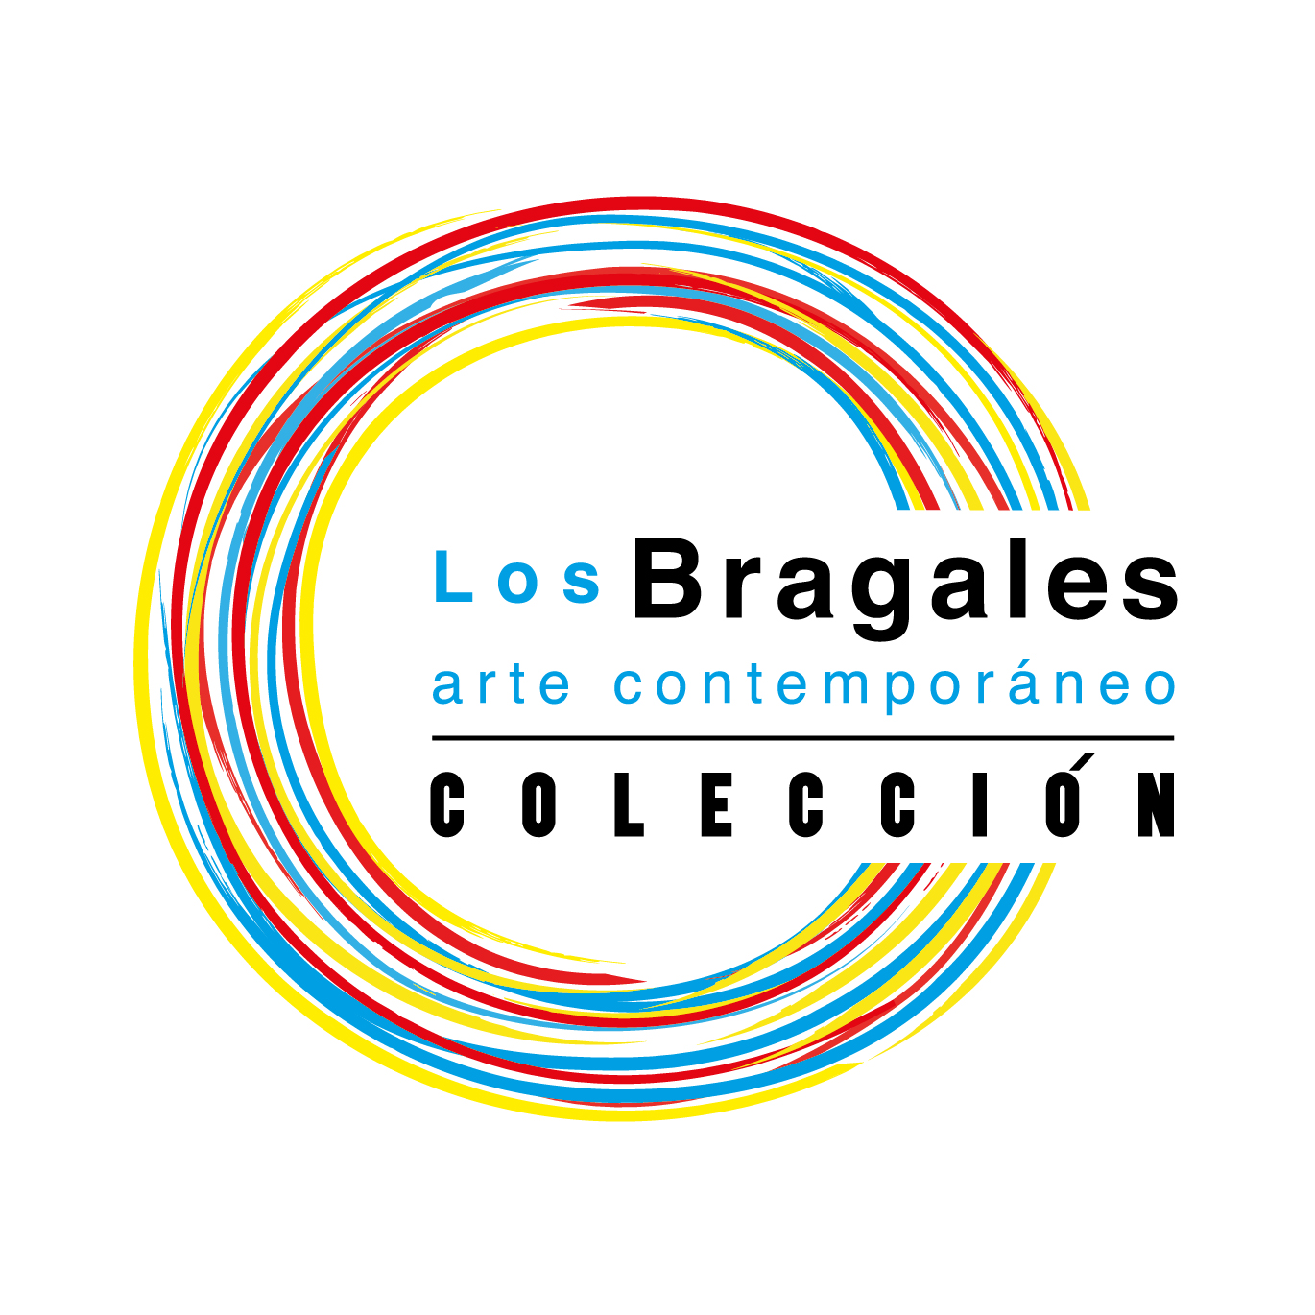
Produced by:
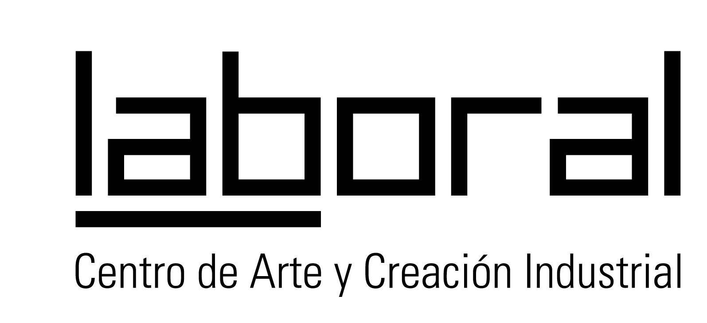

In partnership with:


Acknowledgements:

Visionique studio, fabLAB Asturias, Pinturas Ángel, Lucía Cortina, Raúl Fernández, Rose Cook, Familia Meana Hermida, Ricardo Anadón

