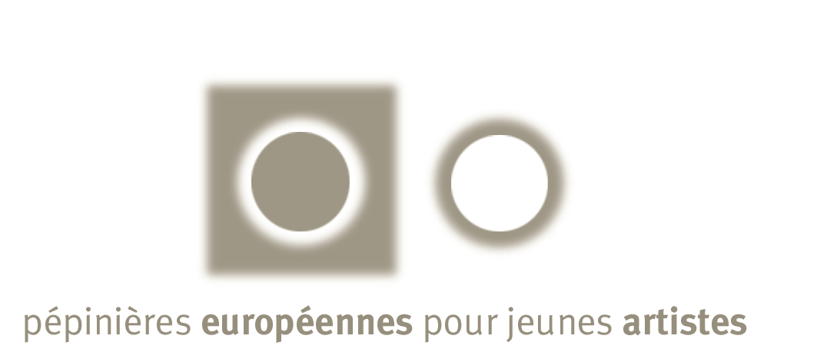
artists in context – artists against exclusion

The artists in context - artists against exclusion programme is an initiative of the Pépinières européennes pour jeunes artistes. It comes within the framework of the European voluntary service. The programme benefit from the partnership of the host organisations, the national co-ordinators, it is financed by the European commission (DG education and culture), the French ministry of culture, the French ministry of youth and sports.

presentation

The Pépinières européennes pour jeunes artistes have been encouraging for more than ten years the emerging creators’ advancement and their professional fulfilment on the European artistic scene through youth’s mobility programme.

Particularly careful to the emergence of a young generation of artists who invents new forms of expression and surely rethinks the artist’ place in his relation to the other, the Pépinières européennes pour jeunes artistes have set up five years ago the “artists in context” project. This mobility programme enables emerging creators between 18 and 25 years old to develop an artistic project dealing with social and human issues

Far away from the usual areas of the contemporary creation, often in unexpected places such as hospitals, prisons, disadvantaged suburbs, isolated rural zones, the creation sites are as many expression fields where venture the stakes of genuine human relations and where are drawn the possible schemes of a new form of artistic commitment.

For the 4th edition of this programme, 14 artists will be hosted in 11 cities of 9 European countries.

modalities

· modalities of participation

Candidates must fulfil the following conditions :
- to be between 18 and 25 years of age,
- to be citizen or legal resident of a country of the European union or a country participating in the programme,
- to be available during all the length of the programme (6 months at least),
- send a completed application form in French or in English.

The participation in the programme is not limited to a specific artistic education and it concerns several artistic expression fields. There is no application fee.

· presentation of the application form

The file must include the following elements :
- the form completed and signed,
- a curriculum vitae,
- a motivation letter explaining the importance you intend to give to this experience in your artistic process,
- iconographic materials and any document necessary for the understanding of your artistic process.

· selection process

A selection committee composed of experts will examine the applications to make the pre-selection. The pre-selected files will then be submitted to the partner organisations which will decide on the final choice of the candidate(s).
The laureates will be informed of the results by post at every stage.

· modalities of hosting

The artist’s project is led in close collaboration with the host organisation which ensures the training as well as the follow up and guiding of the artist during all the residency.
The artists receive board and lodging as well as a monthly allowance ranging from 140 to 210 euros depending on the country. Their travels are also covered (different seminars, travel from home to the place of residency and return). They are insured (civil liability, illness, accident, judicial assistance).

A seminar of preparation will be organised by the Pépinières européennes pour jeunes artistes before the residencies start. This seminar will allow the organisations managers and the laureates to meet and to tackle all questions that are essential for the good progress of the artists’ stay.

An agreement will be established between the artist, the partner organisation and the sending organisation in order to define every one’s responsibilities.

Once all residencies are over, all of the participants in the programme (organisations, artists, professionals, financial supporters, but also the public) will be invited to meet so as to exchange their experiences, to discuss issues the residency, the European voluntary service imply. It is an opportunity for the artists to present to the professionals but also to the public the works achieved.

A certificate will be given by the European commission to each candidate who will have completed their European voluntary service.

· list of the hosting organisations

country | city | partner organisations | fields of expression | nb of invited artists
Germany | Berlin | Schlesische 27 | digital arts, multimedia | 1
Belgium | Sint Jans Molenbeek - Bruxelles | De Vaartkapoen | music, theatre, visual arts | 1
Scotland | Lumsden | Scottish Sculpture Workshop | photography, digital arts, video, multimedia | 1
Spain | Huesca | City hall of Huesca | multidisciplinary (sculpture, painting, photography, theatre, music, literature…) | 2
France | Fougères | Arcade | visual arts | 2
 | Marseille | Association Arts et Développement | visual arts, street painting | 2
 | Aix-en-Provence | Ecole des Beaux arts | digital arts, multimedia | 1
Greece | Thessalonique | Arteneon | theatre, visual arts | 1
Poland | Lublin | Fondation de Pologne | Visual arts, installation, performing arts | 1
Portugal | Porto | Espaço T | Photography, dance, theatre | 1
Romania | Bucharest | Centre Multi Art Danse | dance | 1

· for all information
Diane Monserat
Céline Nannini
Pépinières européennes pour jeunes artistes
BP 13 – 9/11 rue Paul Leplat
78164 Marly le Roi cedex
tel : 33 (0)1 39 17 11 00
fax : 33 (0)1 39 17 11 09
email : info@art4eu.net
site : www.art4eu.net

